DAIRY MANAGEMENT SYSTEM

Chinmay Arora RA1911003010298

Ritvik Gupta RA191100301301

TABLE OF CONTENTS

* System description
* Supply chain
* Data dictionaries
* Entity Relationship Diagram
* Select Statements using Different Functions
* Select Statements using Count and Group Functions
* Select Statements using Different Joins
* Insert statement
* Update statement
* Delete statement

SYSTEM DESCRIPTION

This project is based on Diary marketing consisting of four tables Milk packets having all the attributes describing milk packets like its capacity manufacturing date and it’s unique ID and the table is linked to customer table which consist of details about the customers like their name and aadhar card number{No redundancy} which is required for customer verification and through which customer can login and there is also another table consisting of farm details linked to the Milk packet table so that we can get details like location ,owner and ID of the farm from where the milk packet is manufactured and this table is linked to another table farmer which have details about the farmers working at different farms so that farmers can login through his credentials that are Unique Id and aadhar card number of the farmer. So in total our system consist of four different table interacting with the help of foreign keys with each other for the smooth functioning of the system.

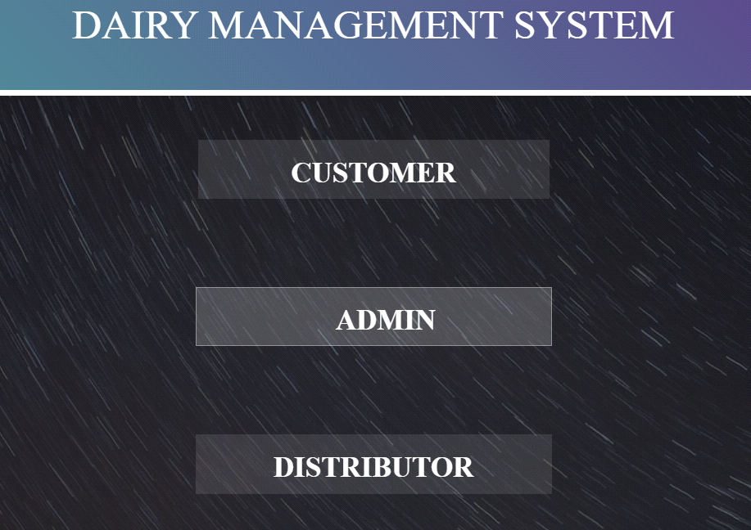

SUPPLY CHAIN

|  |
| --- |
|  |
| **FARM** |

|  |
| --- |
|  |
| **FARMER** |
|  | | |
| **MILK PACKETS** | | |
|  | |
| **CUSTOMER** | |

DATA Dictionaries

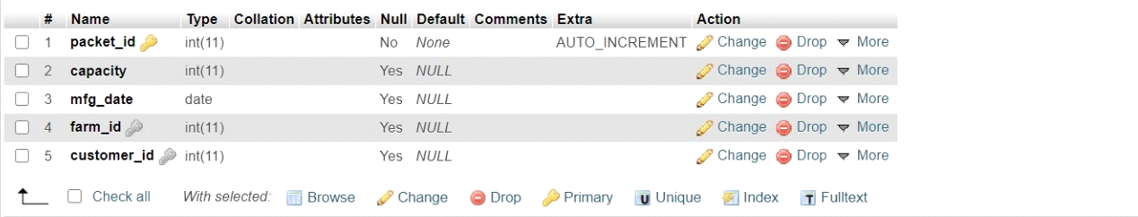**MILK_PACKET**

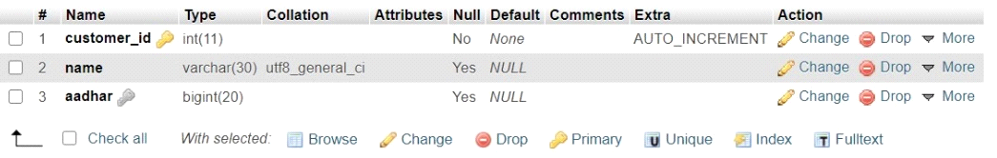**CUSTOMER**

**FARM**

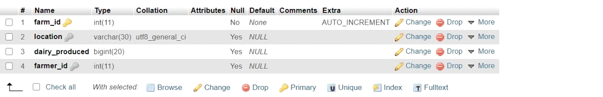

**FARM OWNER**

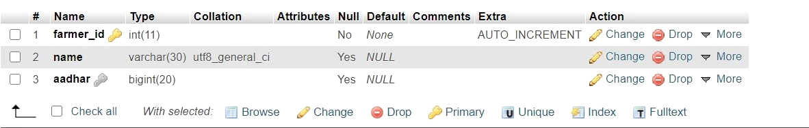

**MILK FACTORY DATABASE**

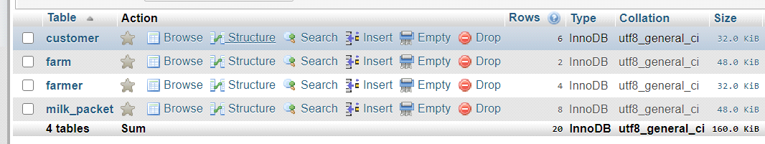

**CODE FOR DATABASE AND TABLE CREATION**

CREATE DATABASE MILK_FACTORY;

GRANT ALL ON MILK_FACTORY.* TO 'kole'@'localhost' IDENTIFIED BY 'swapnil';

GRANT ALL ON MILK_FACTORY.* TO 'kole'@'127.0.0.1' IDENTIFIED BY 'swapnil';

CREATE TABLE Farmer (farmer_id INTEGER NOT NULL AUTO_INCREMENT PRIMARY KEY, name VARCHAR(30), aadhar BIGINT, index(aadhar)) ENGINE=InnoDB CHARSET=utf8;

CREATE TABLE Farm ( farm_id INTEGER NOT NULL AUTO_INCREMENT PRIMARY KEY,location VARCHAR(30), dairy_produced BIGINT, farmer_id INTEGER, index(location), CONSTRAINT FOREIGN KEY(farmer_id) REFERENCES farmer (farmer_id) ON DELETE CASCADE ON UPDATE CASCADE) ENGINE=InnoDB CHARSET=utf8;

CREATE TABLE customer ( customer_id INTEGER NOT NULL AUTO_INCREMENT PRIMARY KEY, name VARCHAR(30), aadhar BIGINT, index(aadhar)) ENGINE=InnoDB CHARSET=utf8;

CREATE TABLE milk_packet (packet_id INTEGER NOT NULL AUTO_INCREMENT PRIMARY KEY, capacity INTEGER, mfg_date DATE, farm_id INTEGER, customer_id INTEGER,CONSTRAINT FOREIGN KEY(farm_id) REFERENCES farm (farm_id) ON DELETE CASCADE ON UPDATE CASCADE, CONSTRAINT FOREIGN KEY(customer_id) REFERENCES customer (customer_id) ON DELETE CASCADE ON UPDATE CASCADE) ENGINE=InnoDB CHARSET=utf8;

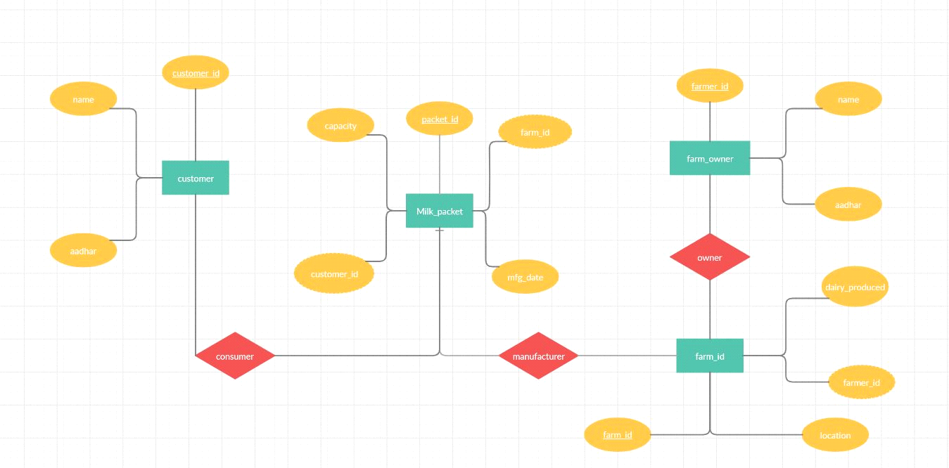Entity Relationship Diagram

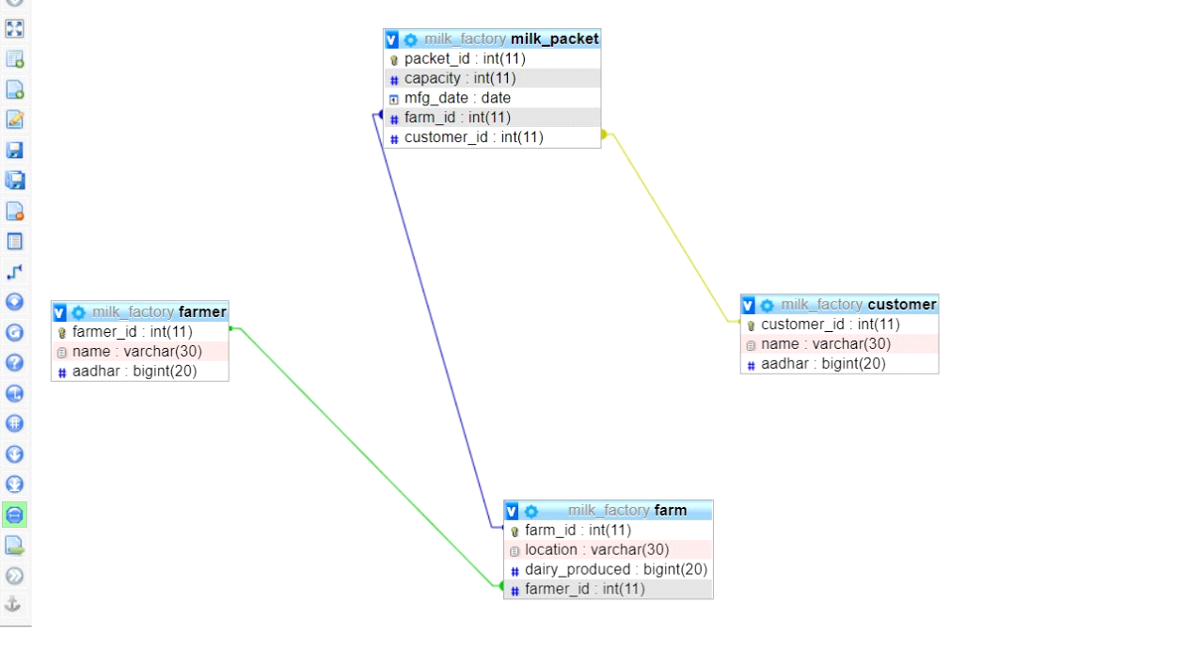

Select Statements using Different Functions

$stmt = $pdo->query("SELECT customer.name,customer.aadhar,customer_id FROM customer");

$stmt = $pdo->query("SELECT farmer.name,farmer.aadhar,farmer_id FROM farmer");

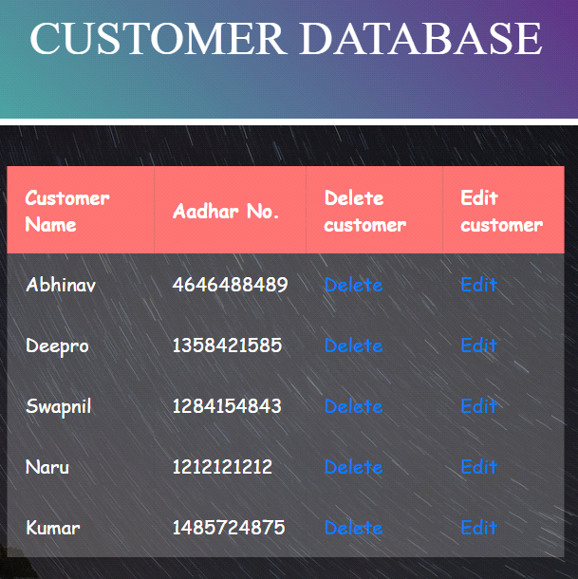 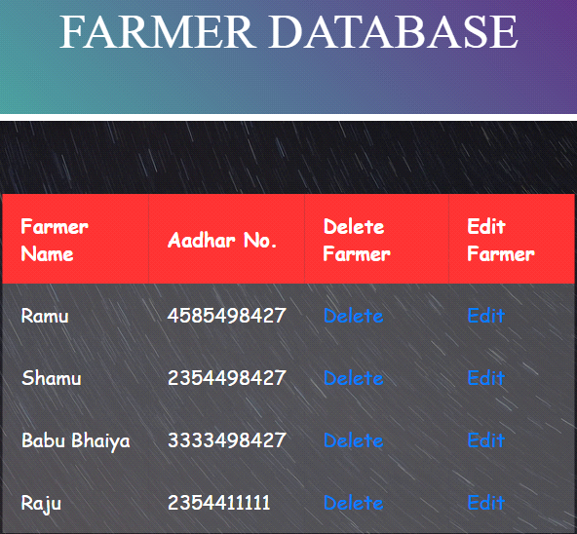

SELECT * FROM milk_packet ORDER BY capacity;

SELECT * FROM farm ORDER BY dairy_produced DESC;

SELECT * FROM customer WHERE name="swapnil";

SELECT packet_id,mfg_date,farm_id FROM milk_packet WHERE farm_id = 8;

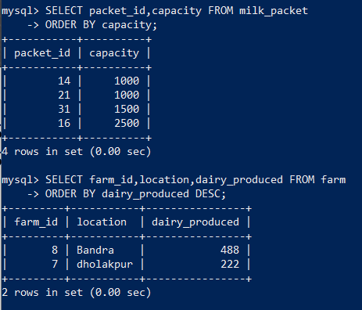 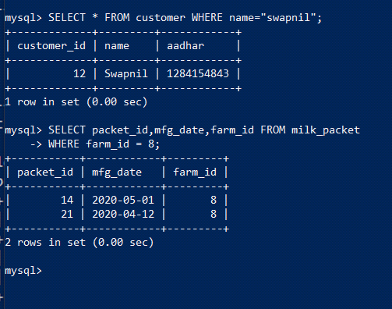

Select Statements using Count and Group Functions

SELECT COUNT(farm_id), dairy_produced FROM farm GROUP BY location;

SELECT COUNT(packet_id), mfg_date FROM milk_packet GROUP BY mfg_date ORDER BY COUNT(packet_id) DESC;

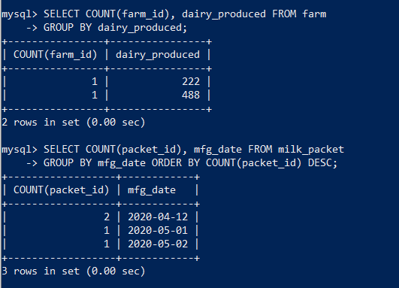

SELECT COUNT(packet_id) FROM milk_packet ;

mysql> SELECT COUNT(farm_id), location FROM farm Group by location;

SELECT COUNT(Aadhar) FROM customer ;

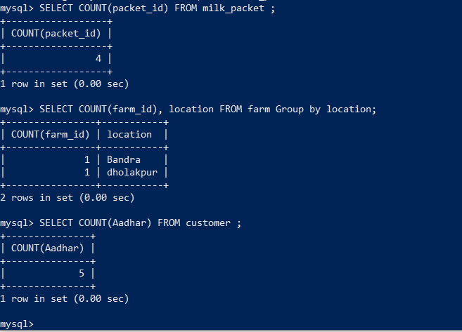

Select Statements using Different Joins

$stmt = $pdo->prepare("SELECT packet_id,mfg_date, capacity,location, farmer.name FROM milk_packet JOIN customer JOIN farm JOIN farmer ON farm.farm_id = farmer.farmer_id and milk_packet.farm_id = farm.farm_id and customer.customer_id = milk_packet.customer_id WHERE customer.aadhar = :aad");

$stmt->execute(array(':aad' => $_POST['Aadhar']));

SELECT customer.name,packet_id,mfg_date,capacity,location,farmer.name FROM milk_packet JOIN customer JOIN farm JOIN farmer ON farm.farmer_id = farmer.farmer_id and milk_packet.farm_id = farm.farm_id and customer.customer_id = milk_packet.customer_id;

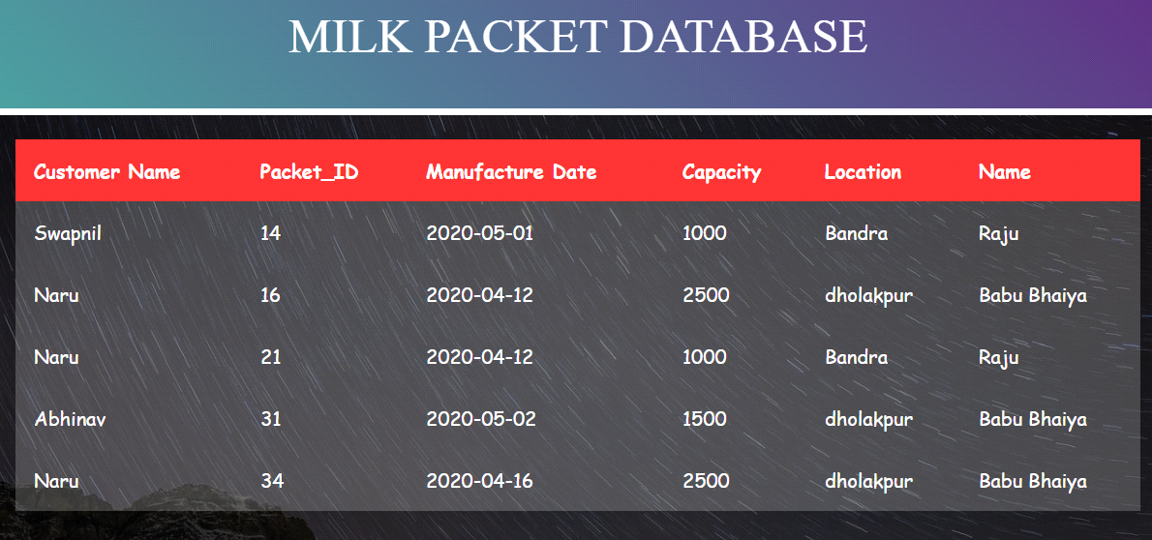

SELECT farmer.name,farm.location,farm.dairy_produced,farm_id FROM farm JOIN

farmer ON farm.farmer_id = farmer.farmer_id;

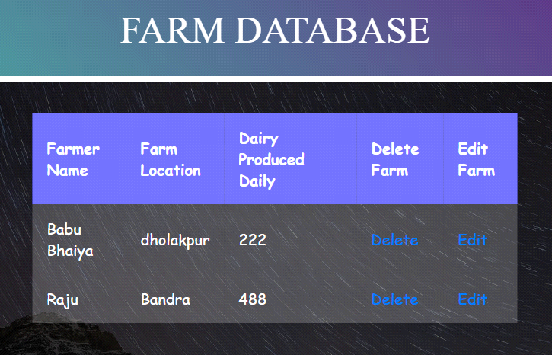

Insert Statement

$stmt = $pdo->prepare("INSERT INTO customer (name,aadhar) VALUES(:name,:aad)");

            $stmt->execute(array(':name' => $_POST['name'],':aad' => $_POST['Aadhar']));

INSERT INTO customer(name,aadhar) VALUES("Swapnil",1429384427);

INSERT INTO customer(name,aadhar) VALUES("Ayush ",1133198427);

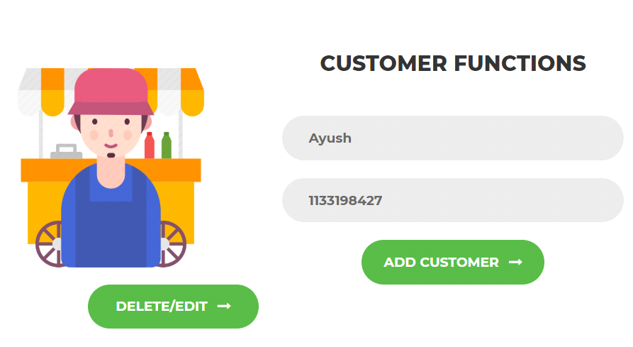 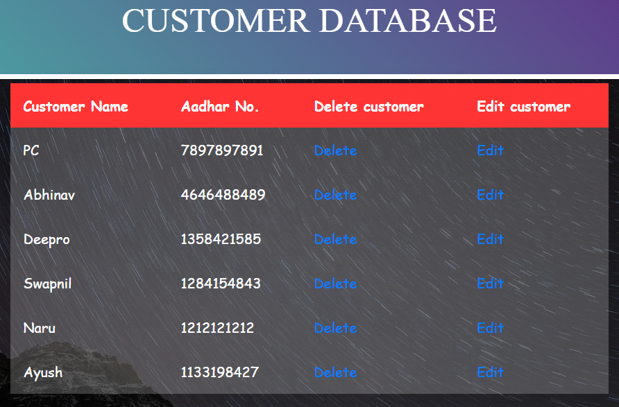

INSERT INTO farmer(name,aadhar) VALUES("Ramu",4585498427);

INSERT INTO farmer(name,aadhar) VALUES("Shamu",2354498427);

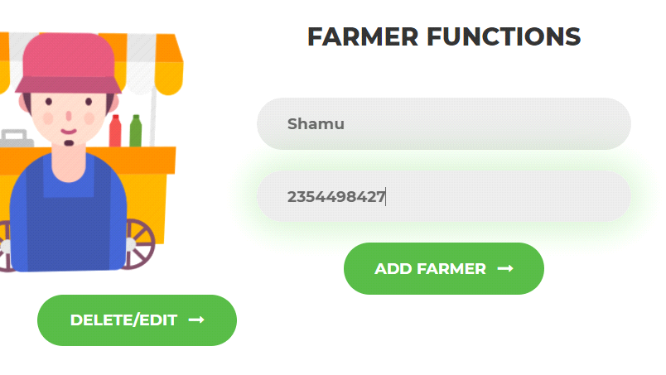 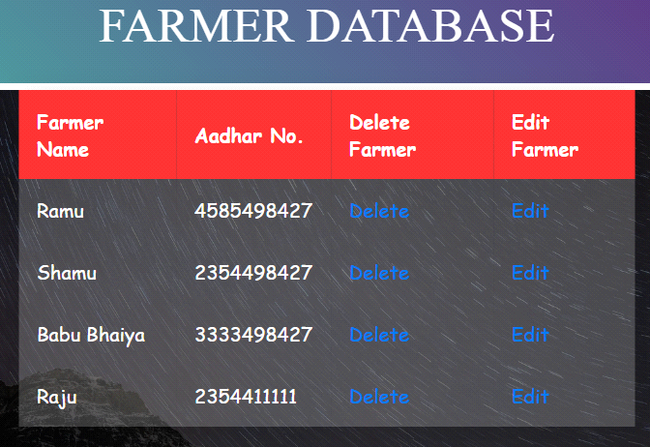

INSERT INTO farm(location,dairy_produced,farmer_id) VALUES("patna",987,1);

INSERT INTO farm(location,dairy_produced,farmer_id) VALUES("khorda",748,2);

INSERT INTO milk_packet(capacity,mfg_date,farm_id,customer_id) VALUES(2500,"2020-07-01",6,9);

INSERT INTO milk_packet(capacity,mfg_date,farm_id,customer_id) VALUES(1500,"2020-05-02",7,10);

Update Statement

$stmt=$pdo->prepare("UPDATE customer SET name=:name,Aadhar=:aad WHERE customer_id=:cid");

$stmt->execute(array(':name'=>$_POST['name'],':aad'=>$_POST['Aadhar'],':cid'=>

$_POST['customer_id']));

UPDATE customer SET name = 'Kumar', Aadhar=1485724875 WHERE customer_id = 16;

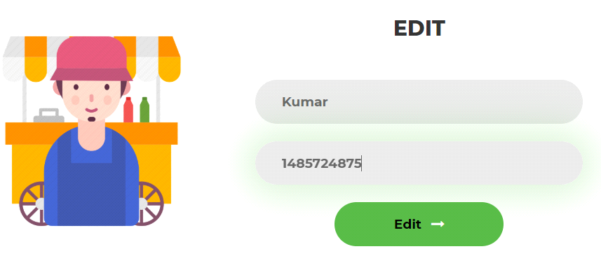 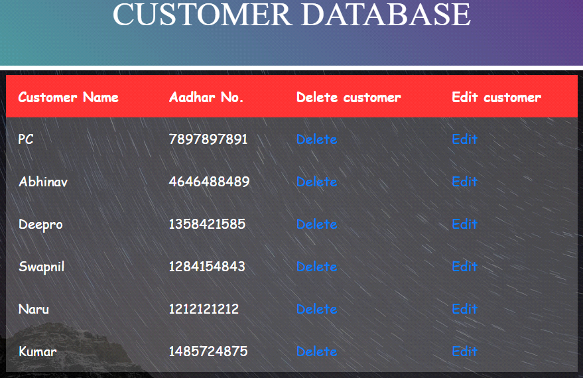

UPDATE customer SET name = 'Priyajeet' WHERE Aadhar = 7897897891;

UPDATE farm SET location='Bandra',dairy_produced = 488,farmer_id = 7 WHERE farm_id = 8;

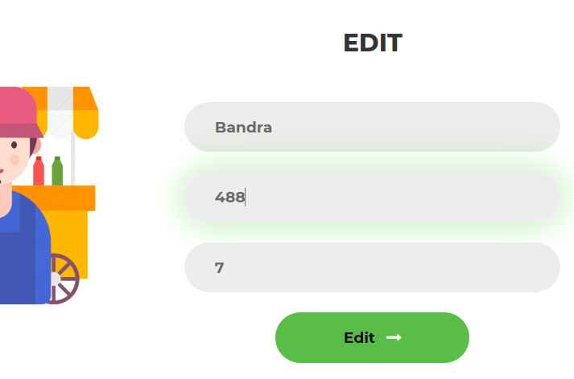 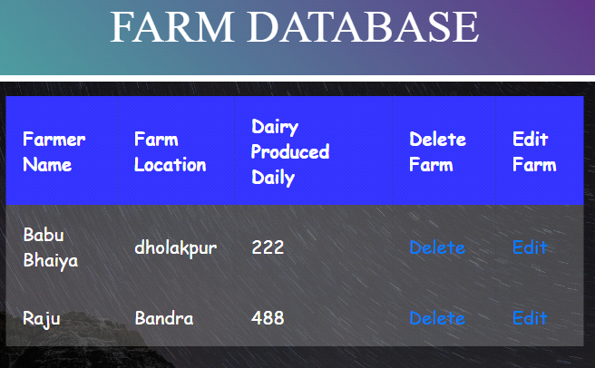

UPDATE farmer SET name = 'Ramu' WHERE farmer_id = :7;

UPDATE farmer SET name = 'Alok' WHERE Aadhar = 4758417812;

Delete Statement

$stmt = $pdo->prepare("DELETE FROM customer WHERE customer_id = :cid");

            $stmt->execute(array(':cid' => $_POST['customer_id']));

DELETE FROM customer WHERE customer_id = 7;

DELETE FROM customer WHERE Aadhar = 7897897891;

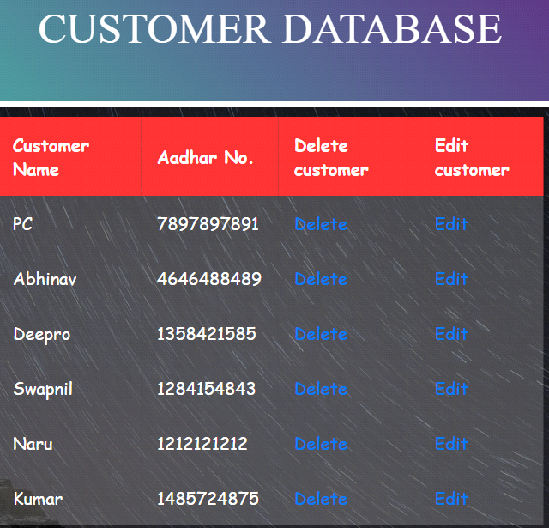 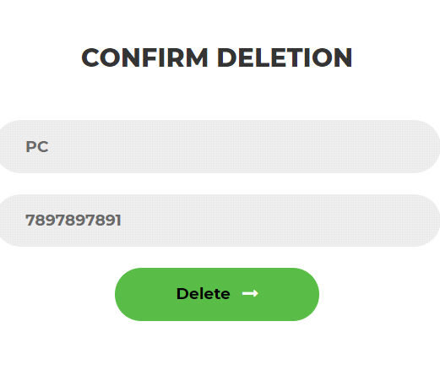 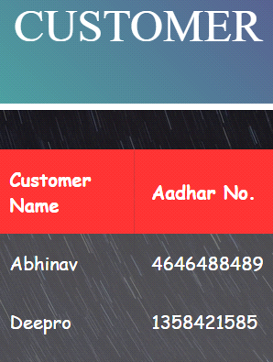

DELETE FROM farm WHERE farm_id = 7;



DELETE FROM farm WHERE location = 'Bandra';



DELETE FROM farm WHERE dairy_produced = 987;



DELETE FROM farmer WHERE Aadhar = 3333498427;

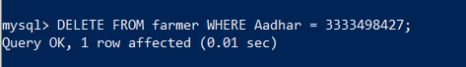

DELETE FROM milk_packet WHERE mfg_date = "2020-05-02";



Thank you